Summary of Improvements to the prototype PPO Drug-Control Model to Version1

This project originally attempted to use Proximal Policy Optimization (PPO) to regulate a simplified one-compartment drug concentration system. However, the agent consistently failed to increase the drug concentration toward the target value (1.0) and instead learned a degenerate “zero-action” behavior. The final working solution required several key corrections in reward shaping, action sampling, and PPO implementation.
Below is a concise summary of the issues and the final optimizations.

1. Core Problems Identified

Problem 1 — Wrong incentive structure: reward encouraged “doing nothing”

The original reward:

r = -|c_t - 1| - 0.05 a_t^2
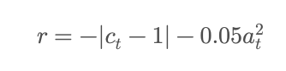
gave very similar values for zero injection vs moderate injection, because:
- error reduction was small
- injection penalty was dominating
- early exploration had low variance → agent almost always sampled small/negative actions
- actions were clipped to [0,2] → many actions became exactly 0

Result: the agent discovered that “inject nothing” is a safe local optimum.

Problem 2 — Action sampling was inconsistent

The PPO policy produced:

a \sim \mathcal{N}(\mu,\sigma)
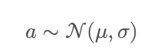
but because of clipping to [0,2], most early actions collapsed to 0.
Furthermore, PPO requires computing log-probabilities of raw actions, not the clipped ones—otherwise gradient estimates become inconsistent.

Result: PPO could not learn a meaningful policy, since the agent never experienced successful increases in concentration.

Problem 3 — Incorrect gradient signal from value function

Using raw rewards and unstable advantages caused high-variance learning and prevented the policy from discovering beneficial behaviors.

2. Key Fixes Implemented

Fix 1 — Stronger reward shaping (critical)

We adopted the stronger quadratic penalty (your choice “B”):

r = -6(c_t - 1)^2 - 0.01 a_t^2
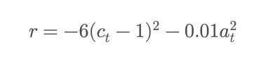
Why this works:
- quadratic error gives a smoother and stronger gradient
- multiplier 6 makes deviation expensive, pulling the agent toward the target
- injection penalty still prevents excessive dosing but no longer overwhelms learning

This made “moving toward the target concentration” significantly more rewarding.

Fix 2 — Correct PPO action pipeline

We separated:
- raw_action (from Normal distribution)
- env_action (clipped to [0,2] and fed into environment)

PPO uses:

\log \pi_\theta(\text{raw\_action})
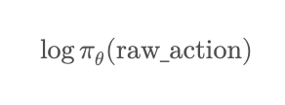
Environment uses:

a_\text{env} = \text{clip(raw\_action)}
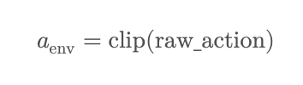
This is the correct PPO design.

Fix 3 — Increased policy exploration

We increased the policy’s initial standard deviation:

\log\sigma = -0.7 \quad (\sigma \approx 0.5)
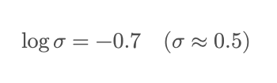
This encourages early exploration, preventing premature collapse to zero actions.

Fix 4 — Stable PPO training components

We used standard PPO elements:
- Clipped objective
L^\text{CLIP} = \min(r_t A_t,\; \text{clip}(r_t,1-\epsilon,1+\epsilon)A_t)
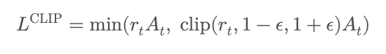
- Value loss
L^\text{value} = (V(s_t) - R_t)^2
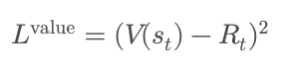
- Entropy bonus to maintain exploration
L^\text{entropy} = -0.01\, H(\pi_\theta)
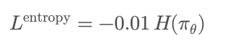
- Multiple PPO epochs per rollout to stabilise updates

These ensure stable and consistent policy improvement.

3. Final Outcome

After applying the above modifications:
- The agent quickly learned to increase concentration from 0.5 to ~1.0
- It then performed fine-grained control to keep concentrations near the target
- Oscillations reduced significantly
- PPO loss and reward curves became stable
- The final concentration curve matches the target line closely (your final plot)

4. One-Paragraph Version (very compact)

We corrected the failed PPO learning by applying proper reward shaping, action sampling, and PPO implementation. The original reward unintentionally encouraged zero injections, so we adopted a stronger quadratic penalty -6(c_t-1)^2 to provide a clearer gradient toward the target concentration. We also separated raw policy actions (used for log-probabilities) from clipped environment actions, increased exploration by raising the initial policy variance, and applied standard PPO mechanisms including clipped ratios, multiple epochs, and entropy regularization. After these improvements, the agent successfully learned stable drug-dosing behavior and maintained the concentration at the target level.

Prototype
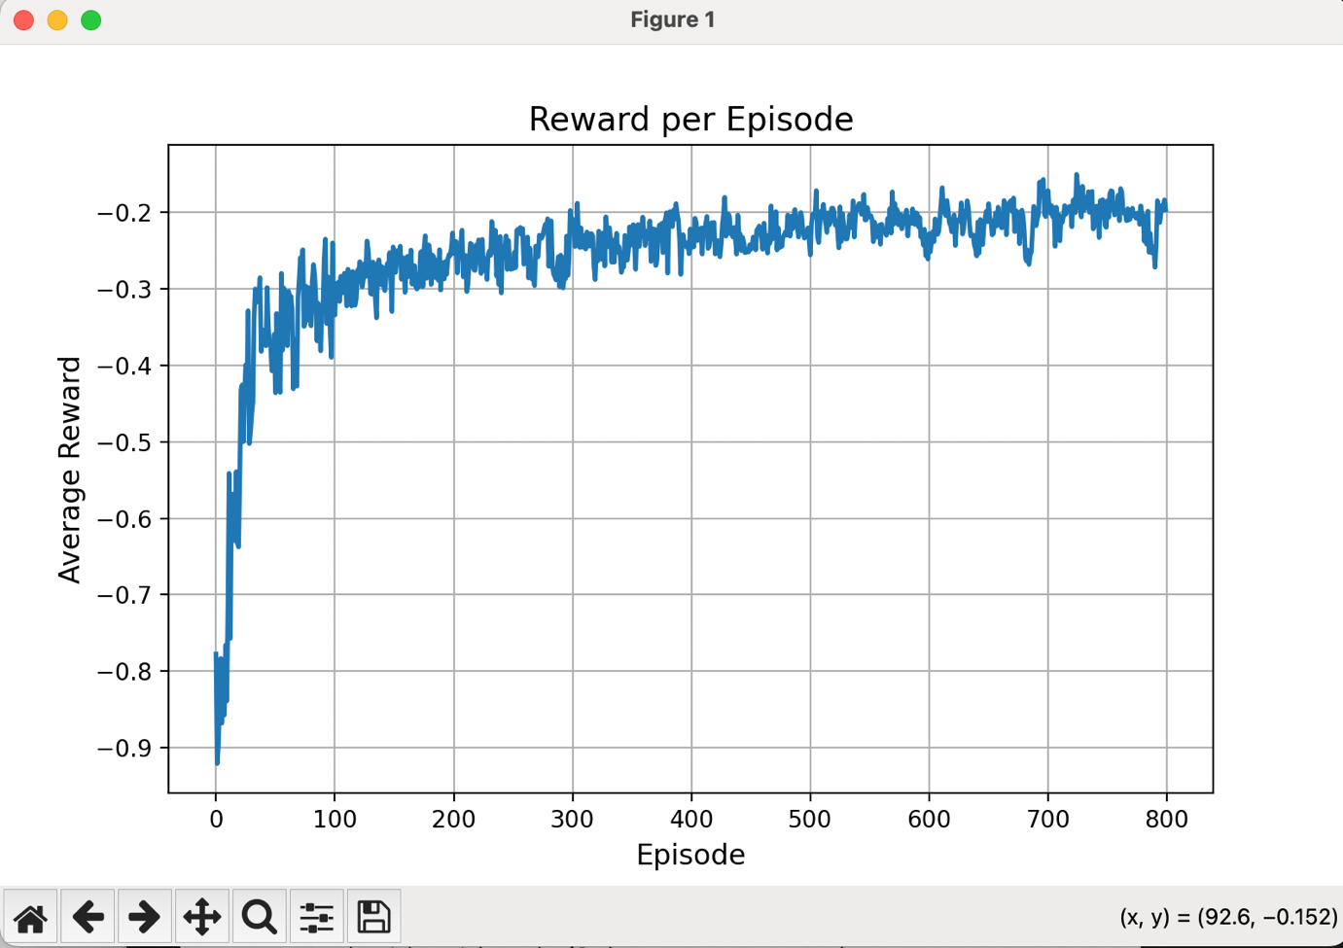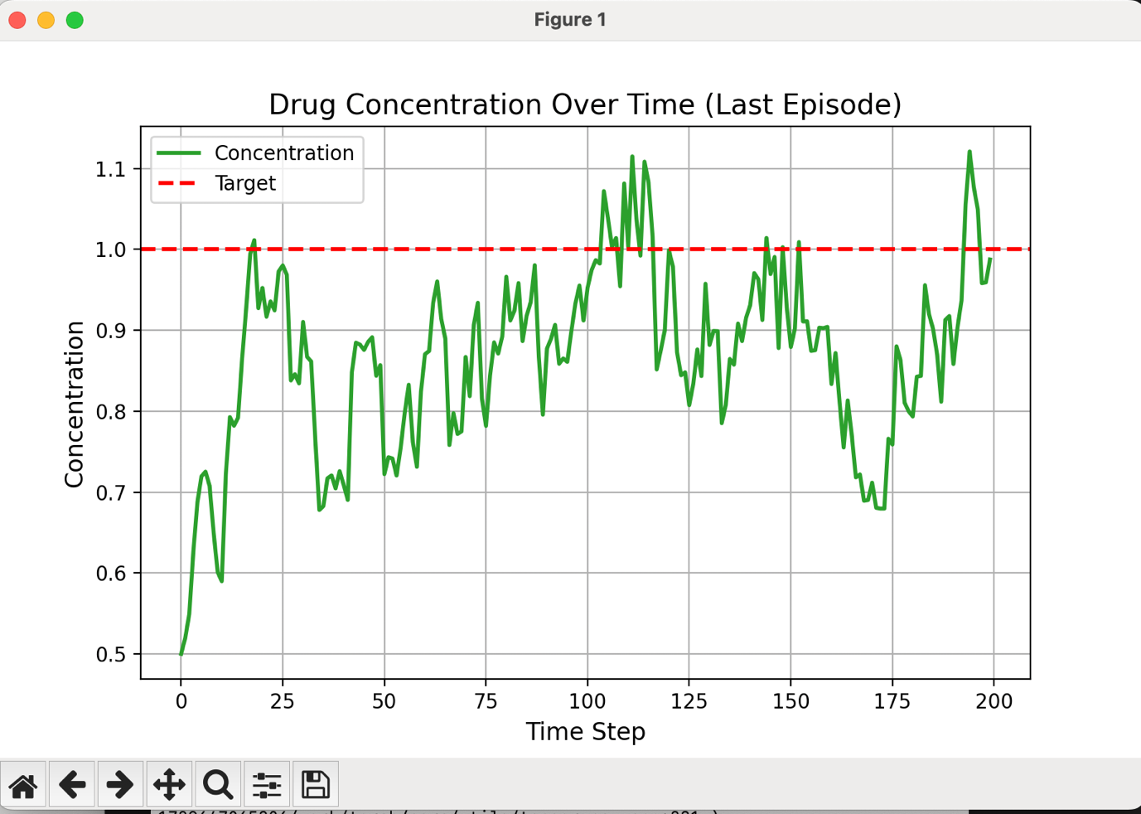
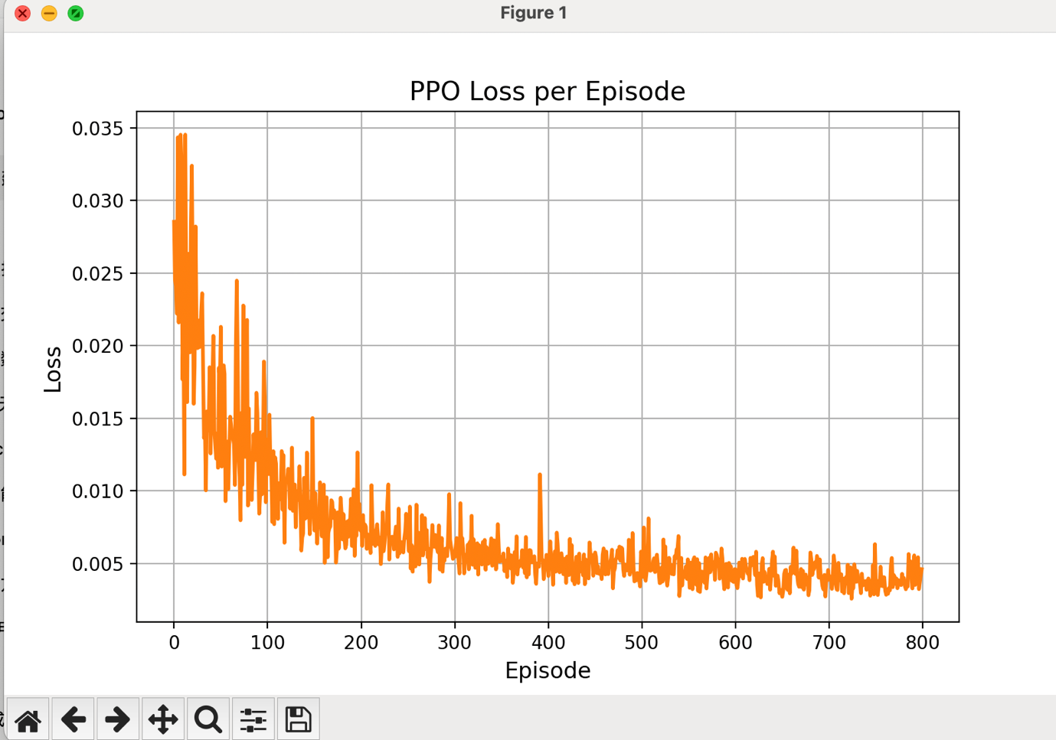

Version1
Episode 50/800, AvgReward: -0.130, Loss: 3.8678
Episode 100/800, AvgReward: -0.076, Loss: 1.4233
Episode 150/800, AvgReward: -0.037, Loss: 0.2765
Episode 200/800, AvgReward: -0.027, Loss: 0.1237
Episode 250/800, AvgReward: -0.025, Loss: 0.1261
Episode 300/800, AvgReward: -0.023, Loss: 0.0691
Episode 350/800, AvgReward: -0.025, Loss: 0.1012
Episode 400/800, AvgReward: -0.021, Loss: 0.0501
Episode 450/800, AvgReward: -0.022, Loss: 0.0680
Episode 500/800, AvgReward: -0.019, Loss: 0.0530
Episode 550/800, AvgReward: -0.019, Loss: 0.0432
Episode 600/800, AvgReward: -0.018, Loss: 0.0476
Episode 650/800, AvgReward: -0.018, Loss: 0.0485
Episode 700/800, AvgReward: -0.020, Loss: 0.0565
Episode 750/800, AvgReward: -0.019, Loss: 0.0338
Episode 800/800, AvgReward: -0.020, Loss: 0.0576
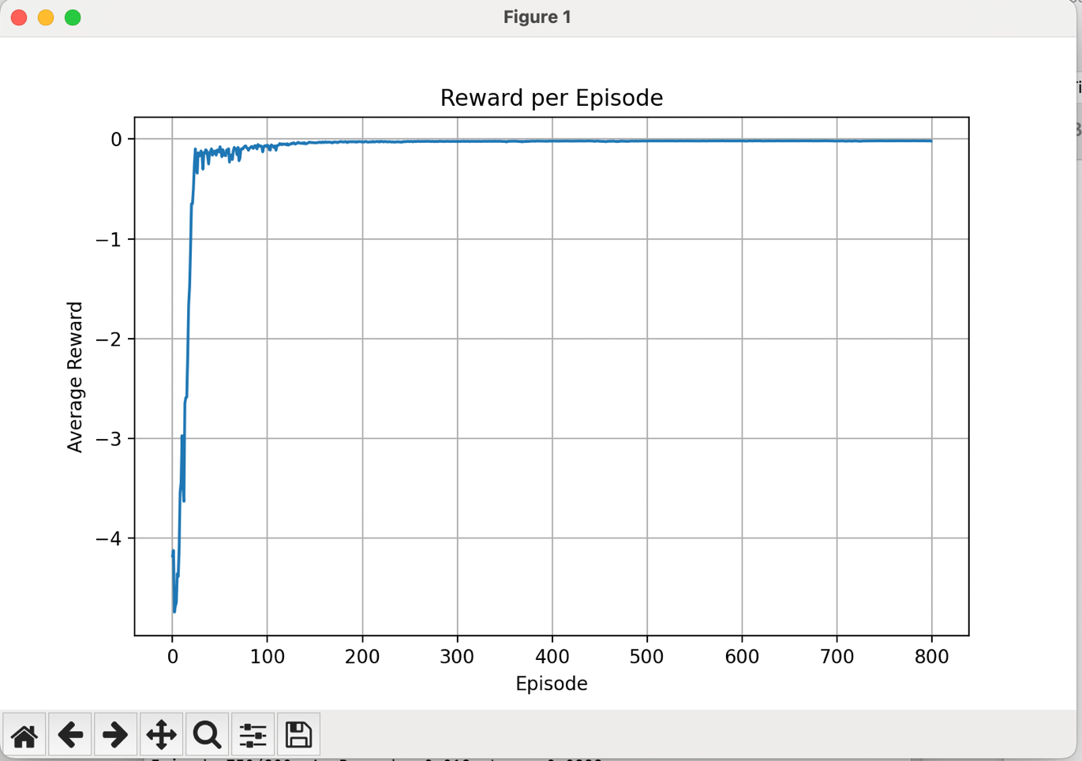
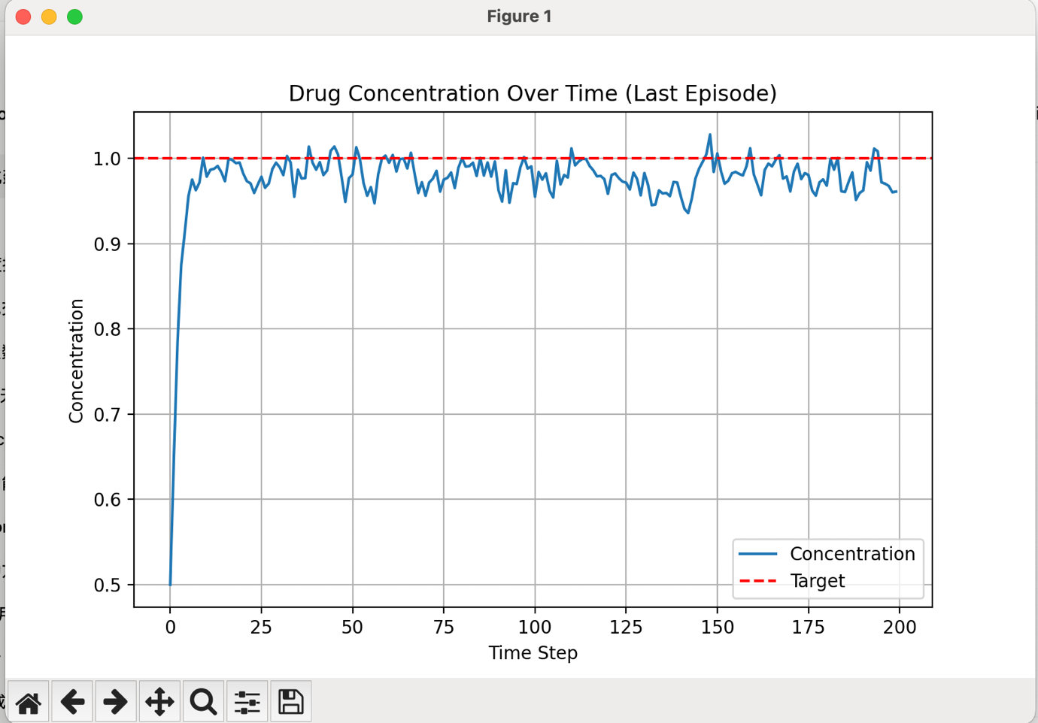
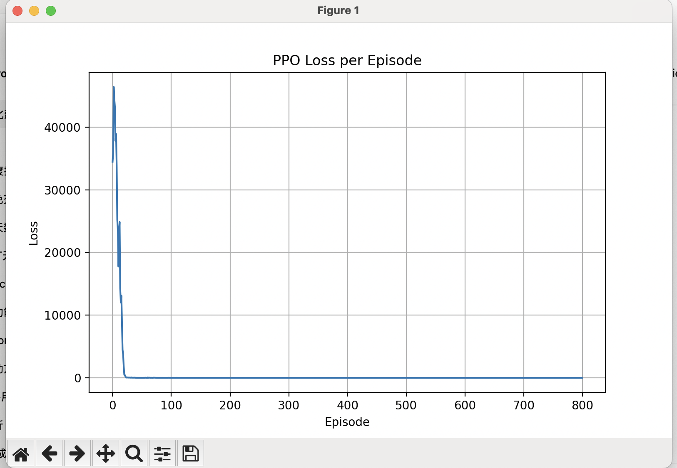
PID:
Kp=20, Ki=2, Kd=4
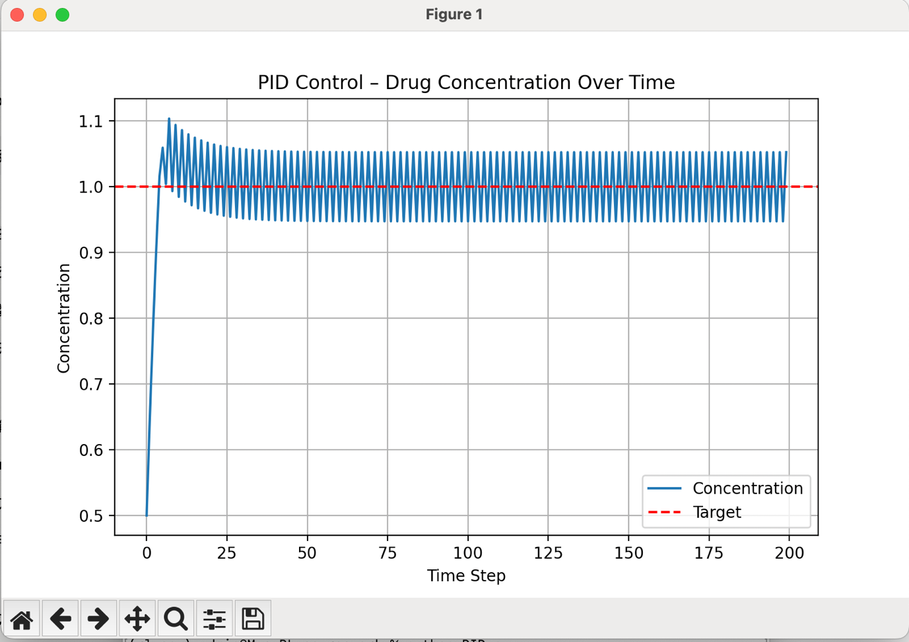
Kp=10, Ki=2, Kd=4
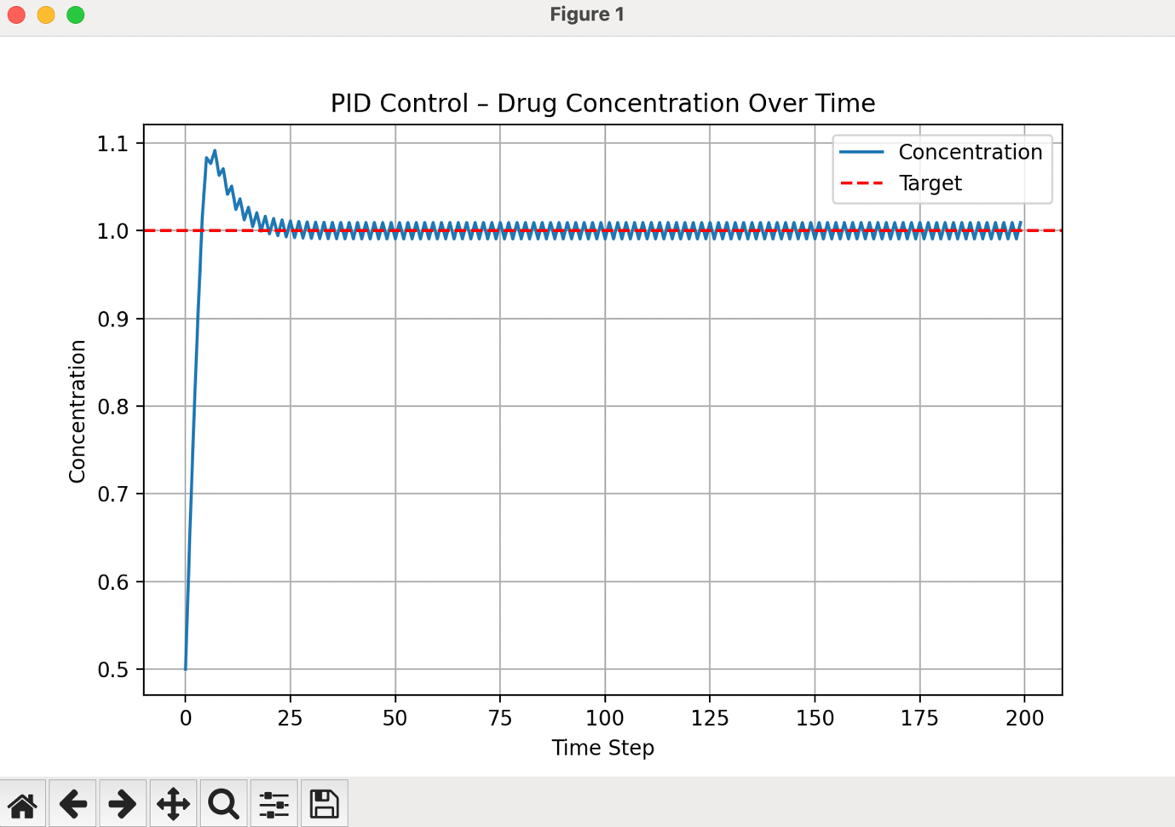
Kp=10, Ki=1, Kd=4
